**KICKSTARTER ANALYSIS**

**Introduction**

Over two billion dollars have been raised using the massively successful crowd-funding service, Kickstarter, but not every project has found success. Of the 300,000+ projects launched on Kickstarter, only a third have made it through the funding process with a positive outcome. Thus, an analysis on a sample of four thousand past projects from Kickstarter has been conducted to uncover any hidden

trends.

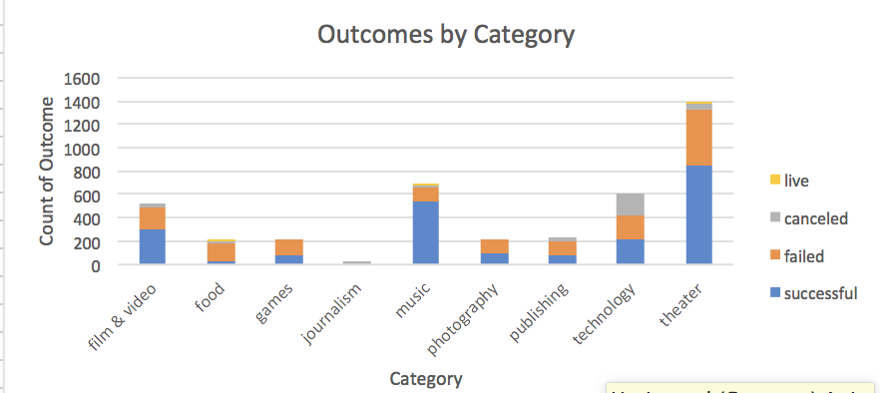

**Outcomes by Category**

Each of the 4,113 projects has been grouped into one of nine main categories. From this sample, the most popular categories were theater, music, and technology. Technology had the most canceled projects while music had the most successful relative to the number in that category. Food had the most relative failures while theater had the most failures overall.

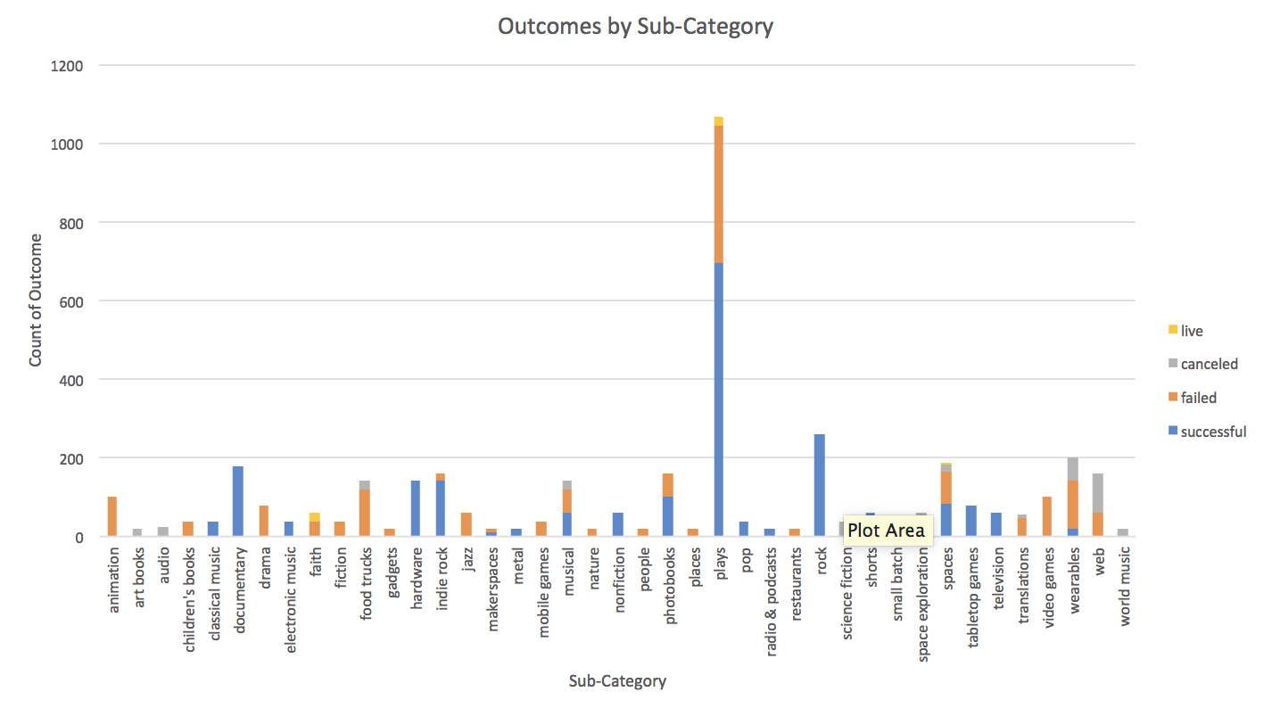

**Outcomes by Sub-Category**

In addition to a main category, each project was assigned a sub-category. Of the 40 sub-categories, plays were the most common. The US had more projects than any other country in the sample. Many sub-categories had only successful outcomes; this includes rock music, classical music, electronic music, metal music, pop music, radio & podcast, nonfiction publishing, places photography, hardware electronics, short film, documentary film, table top game, and television projects.

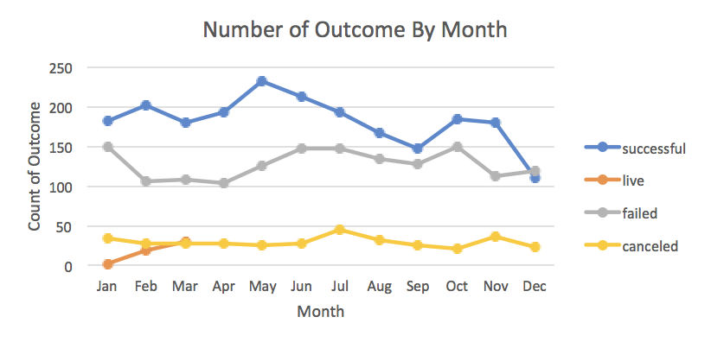

**Outcomes by Month**

More Kickstarter projects were launched in May, June, and July than other months. December had the least project launches and was the only month where the number of failed projects exceeded the number of successful projects. While half of the July projects were successful, more projects were cancelled in this month than any other month.

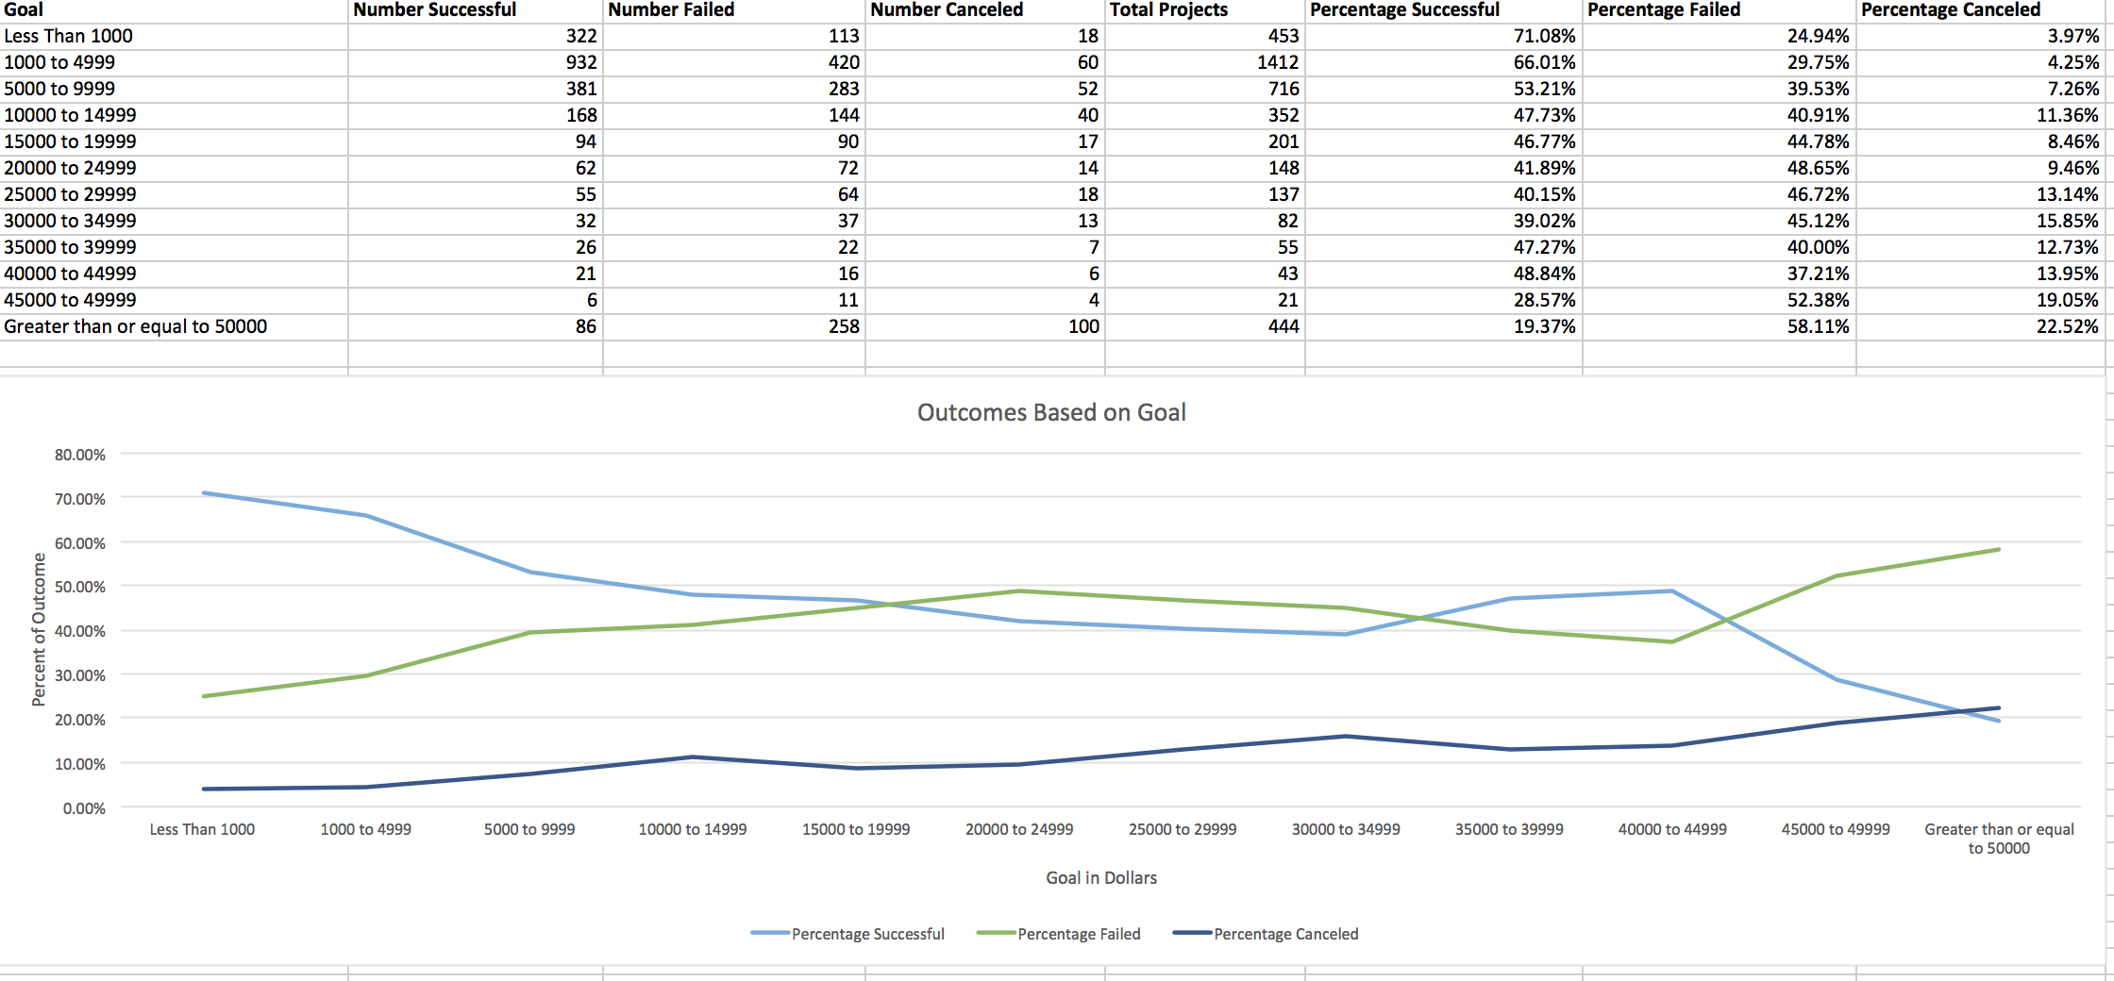

**Outcomes by Goal**

As would be expected, lower fundraising goals had higher rates of success than higher goals. Projects with higher goals had higher rates of project cancellation than projects with lower goals. For projects with goals between $15,000 and $35,000, the percent of failed projects was higher than the percent of successful projects.

**Conclusions**

1. Music related projects are the most popular and most successful.
2. Projects launched in December have more failed projects than successful projects.
3. Lower goals have higher rates of success while higher goals have higher rates of cancellation.

**Limitations**

This dataset lists all of the fundraising goals and funded amounts in different currencies without providing conversion rates at the time launched. While this doesn’t affect analysis on percent funded, it incorrectly groups projects by goal amount without the ability to accurately standardize the currencies. It has data for project start dates ending after the first quarter of 2017 and starting mid year in 2009, leading to a false seasonality effect. It also is a smaller sample size that seems to disproportionally represent US projects.

**Other Visualizations**

We could make a line graph that shows the duration of the project (date ended – date created) with the percent of each outcome. We could create a bar graph of the number of projects per year to show the general growth of Kickstarter since 2009. We could also create a pie chart of the countries with projects on Kickstarter to understand the sample population better.